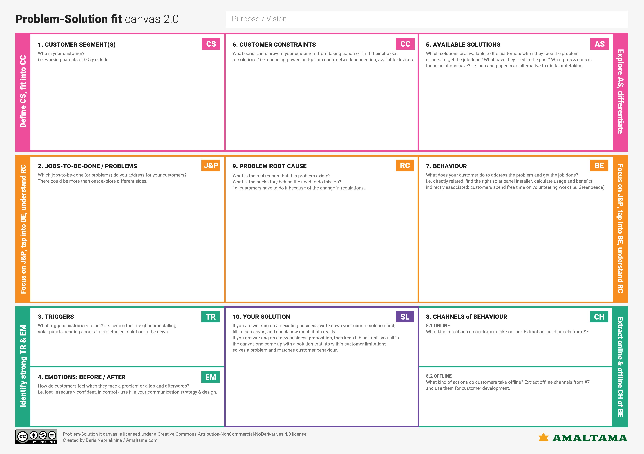

Companies and users who want to ensure they are using a safe URLS to make online transactions.

Awareness of email scams and wanting protection against it.

Educate themselves on the various types of phishing attacks.

Helping customers avert identity theft and keep their transactions from falling into the wrong hands.

Before, fear of losing our private information and after, a feeling secure and confident in making internet transactions.

Using ML algorithms to identify Phishing URL’s using a set of features giving users the ability to verify whether they are using a safe site to make transactions.

Internet transactions and the degree of sophistication with which personal information can be accessed by malicious actors.

Consult Cyber Security Analysts.

SSL Certificate can be used to secure all traffic to and from website protecting information being sent between your web sever and your customers browser from eavesdropping.

As phishing attacks become more sophisticated, the harder it becomes to detect them. Also, lack of awareness of phishing attacks.

Check the SSL certification of the URL’s being used. Check their domain names in the database.